Part I. Paper Assignment

1. This problem examines conversions between various filter specifications. Given the absolute specifications $δ_{s}=0.0001$ and $ω_{p}=0.3π$, $ω_{s}=0.5π$, determine the relative specifications $A_{s}$ and $ω_{c}$, ∆𝜔.

$A_{S}=-20\log_{10}{δ_{s}}=80 dB$, $ω_{c}=\frac{ω_{p}+ω_{s}}{2}=0.4π,$ $∆ω=ω_{s}-ω_{P}=0.2π$

1. The Hann window function can be written as $w\left[n\right]=\left[0.5-0.5\cos\left(2πn/M\right)\right]w_{R}\left[n\right]$ where $w_{R}[n]$ is the rectangular window of length M + 1.
2. Express the DTFT of w[n] in terms of the DTFT of $w_{R}[n]$.
3. Explain why the Hann window has the wider mainlobe but lower sidelobes than the rectangular window of the same length.

$x\left[n\right]\cos{(ω_{c}n)}↔\frac{1}{2}X\left(e^{j\left(ω+ω_{c}\right)}\right)+\frac{1}{2}X\left(e^{j\left(ω-ω_{c}\right)}\right)$

$⇒W\left(e^{jω}\right)=\frac{1}{2}W_{R}\left(e^{jω}\right)-\frac{1}{4}\left(W_{R}\left(e^{j\left(ω+\frac{2π}{M}\right)}\right)+W_{R}\left(e^{j\left(ω-\frac{2π}{M}\right)}\right)\right)$

1. Hann window用原本一半的Rectangular window再減掉1/4往左右平移 $e^{j2π/M}$ 的Rectangular訊號，也因此Hann window會有比較寬的mainlobe和比較小的sidelobes。
2. Consider a FIR filter with impulse response h[n] = u[n] − u[n − 4].
3. Determine and sketch the magnitude response $|H\left(e^{jω}\right)|$.
4. Determine and sketch the amplitude response $A\left(e^{jω}\right)$. Compare this sketch with that in (a) and comment on the difference.
5. Determine and sketch the phase response $∠H\left(e^{jω}\right)$.
6. Determine and sketch the angle response $Ψ\left(e^{jω}\right)$. Compare this sketch with that in (c) and comment on the difference.

$H\left(e^{jω}\right)=\frac{1-e^{-j4ω}}{1-e^{jω}}⇒\left|H\left(e^{jω}\right)\right|=\left|\frac{1-\cos{4ω}+j\sin{4ω}}{1-\cos{ω}-j\sin{ω}}\right|$

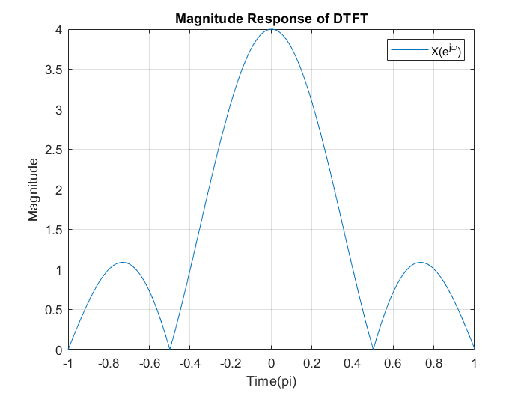

1. Odd order M; even tap L = M + 1, symmetric 🡪 Type II

$H\left(e^{jω}\right)=h\left[0\right]+h\left[1\right]e^{-jω}+h\left[2\right]e^{-j2ω}+h\left[3\right]e^{-j3ω}=\left(2h\left[1\right]\cos\left(\frac{ω}{2}\right)+2h\left[0\right]\cos\left(\frac{3ω}{2}\right)\right)e^{-j\left(\frac{3}{2}\right)ω}=A\left(e^{jω}\right)e^{-j\left(\frac{3}{2}\right)ω}$

$⇒A\left(e^{jω}\right)=\left(2\cos\left(\frac{ω}{2}\right)+2\cos\left(\frac{3ω}{2}\right)\right)e^{-j\left(\frac{3}{2}\right)ω}$

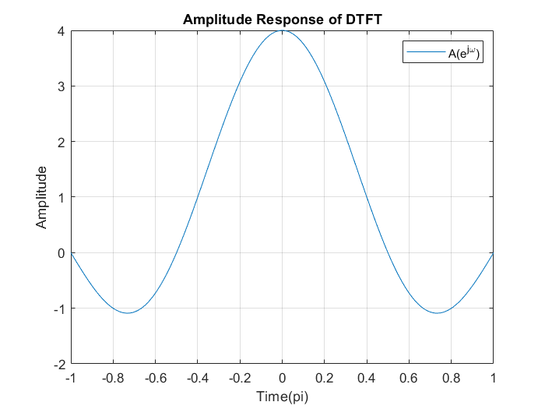

$⇒\left|A\left(e^{jω}\right)\right|=H\left(e^{jω}\right)$

$H\left(e^{jω}\right)=\frac{1-e^{-j4ω}}{1-e^{jω}}=\left|H\left(e^{jω}\right)\right|e^{j∠H\left(e^{jω}\right)}$

$⇒∠H\left(e^{jω}\right)=∠\left(1-e^{-j4ω}\right)-∠\left(1-e^{jω}\right)$

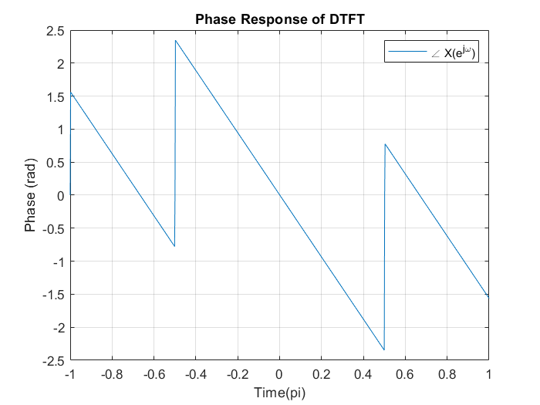

$H\left(e^{jω}\right)=A\left(e^{jω}\right)e^{-j\left(\frac{3}{2}\right)ω}=A\left(e^{jω}\right)e^{jΨ\left(e^{jω}\right)}⇒Ψ\left(e^{jω}\right)=-\left(\frac{3}{2}\right)ω$

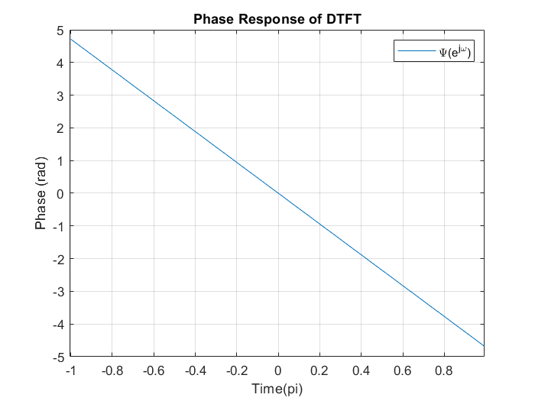

$⇒Ψ\left(e^{jω}\right)=unwrap ∠H\left(e^{jω}\right)$

1. Consider the type-IV linear-phase FIR filter characterized by antisymmetric impulse response and odd-M.
2. Show that the amplitude response $A\left(e^{jω}\right)$ is given by (10.38) with coefficients d[k] given in (10.39).

$H\left(e^{jω}\right)=\sum_{k=1}^{\frac{M+1}{2}}{\left(d\left[k\right]\sin\left[ω\left(k-\frac{1}{2}\right)\right]\right)je^{-\frac{jωM}{2}}}≈jA\left(e^{jω}\right)e^{-\frac{jωM}{2}}$ (10.38)

$d\left[k\right]=2h\left[\frac{M+1}{2}-k\right]$ (10.39)

1. Show that the amplitude response $A\left(e^{jω}\right)$ can be further expressed as (10.40) with coefficients $\hat{d}\left[k\right]$ given in (10.41).

$A\left(e^{jω}\right)=\sin\left(\frac{ω}{2}\right)\sum_{k=0}^{\left(M-1\right)/2}{\tilde{d}\left[k\right]\cos{(ωk)}}$ (10.40)

$d\left[k\right]=\left\{\begin{aligned}\frac{1}{2}(2\tilde{d}\left[0\right]-\tilde{d}\left[1\right]), &k=1 \\ \frac{1}{2}(\tilde{d}\left[k-1\right]-\tilde{d}\left[k\right]), &2≤k≤(M-1)/2 \\ \frac{1}{2}\tilde{d}\left[(M-1)/2\right], &k=(M+1)/2\end{aligned}\right.$ (10.41)

1. $H\left(e^{jω}\right)=\sum_{n=0}^{M}{h[n]e^{-jωn}}$, $h\left[n\right]=h\left[M-n\right]$



$H\left(e^{jω}\right)=h\left[0\right]+h\left[1\right]e^{-jω}+…+h\left[M-1\right]e^{-j(M-1)ω}+h\left[M\right]e^{-jMω}$

$=\left(h\left[0\right]e^{j\frac{M}{2}ω}+h\left[1\right]e^{j\left(\frac{M}{2}-1\right)ω}+…+h\left[M-1\right]e^{-j\left(\frac{M}{2}-1\right)ω}+h[M]e^{-j\frac{M}{2}ω}\right)e^{-j\frac{M}{2}ω}$

$=\left(2h\left[0\right]\sin\left(\frac{M}{2}ω\right)+2h\left[1\right]\sin\left(\left(\frac{M}{2}-1\right)ω\right)+2h\left[2\right]\sin\left(\left(\frac{M}{2}-2\right)ω\right)+…+2h\left[\frac{M-1}{2}\right]\sin\left(\left(\frac{M}{2}-\frac{M-1}{2}\right)ω\right)\right)je^{-j\frac{M}{2}ω}$

$=\left(d\left[k\right]\sin\left(\frac{Mω}{2}\right)+d\left[k-1\right]\sin\left(\left(\frac{M}{2}-1\right)ω\right)+…+d\left[1\right]\sin\left(\frac{ω}{2}\right)\right)je^{-j\left(\frac{M}{2}\right)ω}$

$H\left(e^{jω}\right)=\sum_{k=1}^{\frac{M+1}{2}}{\left(d\left[k\right]\sin\left[ω\left(k-\frac{1}{2}\right)\right]\right)je^{-\frac{jωM}{2}}}=jA\left(e^{jω}\right)e^{-\frac{jωM}{2}}$

$d\left[k\right]=2h\left[\frac{M+1}{2}-k\right]$

$\sin\left(α+β\right)=\sin{α}\cos{β}+\cos{α}\sin{β} →2\sin{β}\cos{α}=\sin\left(α+β\right)-\sin{(α-β)}$

$A\left(e^{jω}\right)=\sum_{k=1}^{\frac{M+1}{2}}{\left(d\left[k\right]\sin\left[ω\left(k-\frac{1}{2}\right)\right]\right)}$

$=d\left[1\right]\sin\left(\frac{ω}{2}\right)+d\left[2\right]\sin\left(\frac{3ω}{2}\right)+…+d\left[k-1\right]\sin\left(\left(\frac{M}{2}-1\right)ω\right)+d\left[k\right]\sin\left(\frac{Mω}{2}\right)$

$=$ $d\left[1\right]\sin\left(\frac{ω}{2}\right)+d\left[2\right]\left(2\sin\left(\frac{ω}{2}\right)\cos\left(ω\right)+\sin\left(\frac{ω}{2}\right)\right)+d\left[3\right]\left(2\sin\left(\frac{ω}{2}\right)\cos\left(2ω\right)+\sin\left(\frac{3ω}{2}\right)\right)+…+d\left[k-1\right]\left(2\sin\left(\frac{ω}{2}\right)\cos\left(\frac{\left(M-3\right)ω}{2}\right)+\sin\left(\frac{\left(M-4\right)ω}{2}\right)\right)+d\left[k\right]\left(2\sin\left(\frac{ω}{2}\right)\cos\left(\frac{\left(M-1\right)ω}{2}\right)+\sin\left(\frac{\left(M-2\right)ω}{2}\right)\right)$

$=\sin\left(\frac{ω}{2}\right)\left[\left(d\left[1\right]+…+d\left[\frac{M+1}{2}\right]\right)+2\left(d\left[2\right]+…+d\left[\frac{M+1}{2}\right]\right)\cos{ω}+2\left(d\left[3\right]+…+d\left[\frac{M+1}{2}\right]\right)\cos{2ω}+…+2d\left[\frac{M+1}{2}\right]\cos\left(\frac{M+1}{2}ω\right)\right]$

$=\sin\left(\frac{ω}{2}\right)\sum_{k=0}^{\left(M-1\right)/2}{\tilde{d}\left[k\right]\cos{(ωk)}}$

* $A\left(e^{jω}\right)=\sin\left(\frac{ω}{2}\right)\sum_{k=0}^{\left(M-1\right)/2}{\tilde{d}\left[k\right]\cos{(ωk)}}$ with

$d\left[k\right]=\left\{\begin{aligned}\frac{1}{2}(2\tilde{d}\left[0\right]-\tilde{d}\left[1\right]), &k=1 \\ \frac{1}{2}(\tilde{d}\left[k-1\right]-\tilde{d}\left[k\right]), &2≤k≤(M-1)/2 \\ \frac{1}{2}\tilde{d}\left[(M-1)/2\right], &k=(M+1)/2\end{aligned}\right.$